Graeme Hugo colloquium
The urban-rural dichotomy in Asia – is it still meaningful?
Gavin Jones
The following are rough notes on what I said at the colloquium. I won’t try to polish them, because it was not a polished presentation, but rather trying to highlight areas of Graeme’s work that interacted with mine.
Recently, I was working on a monograph on urbanization in Indonesia, part of a UNFPA series. In connection with this, I went back to the 1981 ESCAP study – Migration, Urbanization and Development in Indonesia – this was a most impressive study, and although Graeme wrote most chapters, this would not have been evident from the title page, which simply listed it as an ESCAP Country Report. It’s an example of Graeme’s prodigious productivity.
Then in 1987 came the Demographic Dimension in Indonesian Development, co-authored by Graeme, Terry and Valerie Hull and myself. Graeme wrote the chapters on internal migration and urbanization, which made a rich contribution to the book, and indeed could almost have been a whole book on their own, as the original manuscript had to be trimmed considerably in order to keep these topics to their appropriate length in a wide ranging book with a publisher-imposed word limit.
But Salut Muhidin will be saying more about Graeme’s contribution to Indonesian demographic studies, so let me move on.

Graeme is probably best known for his work on international migration.
When we founded the journal Asian Population Studies (APS) in 2003, I asked notable demographers for contributions to the very first issue, to get the journal off to a good start. Of course, Graeme was one of those invited to write a paper, and he wrote on “The new international migration in Asia: challenges for population research”.
Graeme had 2 subsequent papers published in APS – on Chinese and Indian skilled migration to Australia, and on “Migration and development in Malaysia: an emigration perspective” – on the Malaysian diaspora, with particular emphasis on the movement of Malaysians to Australia. The paper included a fascinating analysis of the number of temporary moves into and out of Australia by Malaysia-born persons according to their resident status – a remarkable proportion had more than 10 such moves. (APS, Nov. 2011).
This study drew on Graeme’s research in the Malaysian Second Population Strategic Plan Study, published in 2012. I coordinated this study, and invited Graeme to be the only other non-Malaysian to be part of the team. He did a great job, and one benefit was that Graeme was able to follow up his earlier research into Indonesian migration to Sabah, much of it originating in Flores, from the perspective of the receiving end – Sabah.
Another area where my research intersected with Graeme’s was the work on urban-rural linkages. His book with Tony Champion, New Forms of Urbanization. Beyond the Urban-Rural Dichotomy, 2004 was a very important contribution. Some key points from the book:
They noted that a UN Habitat report in 1996 urged caution in using the data published in the UN World Urbanization Prospects: if you say 45% of the world’s population is living in urban areas, you shouldn’t think of this as a precise percentage, but rather as indicating that somewhere between 40 and 55% are living in urban areas, depending on the criteria used to define what is an “urban centre”.
I did some research in Singapore with Leontine Alkema and Cynthia Lai on urban definitions, in which we compared the level of urbanization in all the world’s countries with what would be expected based on a regression relationship between level of urbanization and factors expected to be related, controlling for whether the definition of urbanization in the country was judged to be restrictive, neutral or generous. The idea was then to examine outliers to see whether they could be explained. The paper was published in 2013 in Journal of Population Research). A key figure from this paper is reproduced on the next page.

Comparison of urbanization estimates for countries with more than 10 per cent difference (absolute) between the alternative estimate of urbanization and the UN estimates for the year 2000.
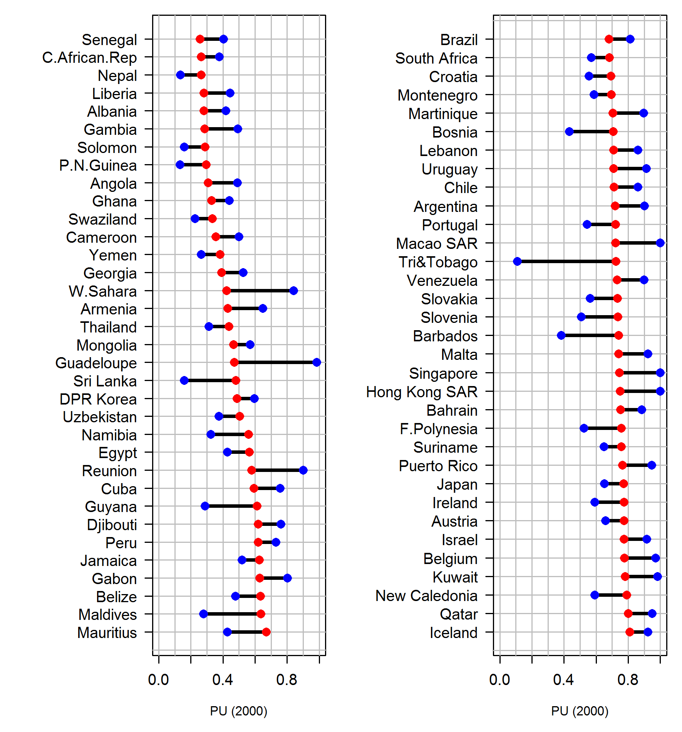

A lot of the outliers are quite small countries. But some are larger – Thailand, Sri Lanka, Brazil, among others. When you investigate particular cases, it’s generally quite easy to discover the reasons why the countries lie outside expected levels of urbanization. But it means that inter-country comparisons of urbanization levels are hazardous, particularly if we compare two countries that lie off the regression line by more than 10% in opposite directions.
Urban agglomerations are another area where some strange figures appear in the UN estimates.
Kuala Lumpur, for example. UN showed 1.5 million until a very recent revision. The real urban agglomeration is more like 6 million, and I see that in their latest revision the UN has finally adopted a more reasonable figure (6.8 million). But they are still underestimating the urban agglomeration for Johor Baru (they give 912,000) and Malaysia’s third largest city - Penang - does not feature in their list at all, despite inclusion of quite a few much smaller Malaysian cities.
The UN urban definitions and urban agglomeration definitions have to some extent misled a whole generation of users. I don’t blame the UN Population Division for this. They are short staffed, and besides, they have to accept the data that member countries give them. But it’s a fact that some of the urban agglomeration data has been highly misleading.
“The thoroughgoing urbanization of East and Southeast Asia”
But the main focus of my comments today is on whether the urban-rural dichotomy in Asia is still meaningful, and just how “urban” East and Southeast Asia are.
The Champion and Hugo book says:
“There is a widespread feeling that the conventional methods of monitoring urbanization and city growth are not portraying the full picture of the changes now affecting individual urban centres and their wider settlement systems, and indeed that they may no longer be capturing the most important dimensions of these changes.” (p. xx) They also noted that “the task of representing the settlement system is being made progressively more difficult by the blurring of urban-rural distinctions, the increasingly multi-dimensional nature of settlement and the emergence of new urban forms” (p. 11)
They also noted findings from a NAS study that showed differentials by size of city. “With respect to total fertility rates, for instance, it was found that, while the overall urban rate fell short of the rural one by some 1.4 children per women, the rate for cities with over 5 million inhabitants was almost two children per women below that of urban areas with under 100,000 residents. Moreover, there was a regular progression across the five city-size groups recognized.” (p.7)
Another important point they made was that accessibility can also be associated with demographic patterns. They included a table on Australia – Table 1.5, obviously Graeme’s contribution – which showed variation in various fertility and mortality measures between settlements in non-metropolitan Australia grouped by degree of accessibility to facilities.
When they called together the group of experts at the conference on which the book was based, they posed three fundamental questions that needed to be addressed:
- Given recent trends, are simple urban-rural classifications of population still adequate for capturing the increasing complexity of the human settlement patterns that now influence people’s lives and behaviour?
- If not, what are the types of human settlement which need to be differentiated in standard classifications of human settlement systems?
- How can these new concepts of human settlement systems be operationalized and measured in standard data collection systems?
Their notion of a graduation of many indicators from larger cities to smaller cities, down to small towns and rural areas, struck a chord with me. I had done work in Indonesia the 1980s for the National Urban Development Strategy project, where I looked at the structure of employment in areas defined as rural. What I found very clearly was that the share of non-agricultural activities in rural areas was considerably higher in districts closer to the large cities than in districts further from those cities – in other words, a clear distance and accessibility gradation. I argued,
There may be a number of reasons. One is that some cities had spilled over their boundaries, so some of what was being recorded as rural population was really suburban. Another is that factories and service sector establishments built in rural areas were more likely to be located in areas close to the large cities than in areas further away. Another is that rural dwellers in areas close to the large cities could avail themselves of opportunities to commute to urban jobs.
It was not only in regard to their employment structure that rural areas closer to large cities more closely resembled the cities. They also scored better on most indicators. This is consistent with Terry McGee’s theory of desakota regions – those very mixed areas, especially on the fringes of large cities, with a complex mix of activities.
Tony Champion and Graeme asked me to contribute the chapter on Asia in their book, which I did. In the chapter, I touched on some earlier work I had done. In 1997, Gordon Carmichael asked me to contribute a paper to the first issue of the journal Asia Pacific Viewpoint, in a special issue he was editing. And I did, entitling the article “The thoroughgoing urbanization of East and Southeast Asia”. I thought this paper had more or less disappeared without a trace, but I was surprised last year when a leading urban geographer at the National University of Singapore, Tim Bunnell, told me he had always thought this article was very important, and he invited me to come back to Singapore for a round table discussion with Neil Brenner, Professor of Urban theory at Harvard, who is prominent in the field of “planetary urbanization”.
That was an interesting discussion. I learned a lot about the theory of planetary urbanization, which has taken off from key works by Henri Lefebvre and David Harvey – “urbanization theory without an outside”. I found it quite hard to get my head around this material. As Neil Brenner puts it, this approach “casts doubt on established understandings of the urban as a bounded, nodal and relatively self-enclosed socio-spatial condition in favour of more territorially differentiated, morphologically variable, multiscalar and processual conceptualizations”. Quite a mouthful! My own approach to “thoroughgoing urbanization” was much less theorized, focusing rather on aspects of the objective life conditions of those living in areas classified as urban and rural.
My key point really was that it is now very difficult in Asia to find rural dwellers who are essentially cut off from urban ways of life, urban ways of making a living, urban facilities like schools, health services, transportation, and – above all - communications facilities.
Let me just give you some statistics to illustrate the point.
- The number of Indian villages with access to electricity grew from less than 5% in the 1940s to 84% in 1992
- In Bangladesh there are 7 mobile phones to every 10 people. Given that children under 15 are about 30% of the population (but some people have more than one mobile phone), this figure suggests almost universal coverage of mobile phones in Bangladesh, one of the poorest countries in Asia.
- In Laos, only 13% of households don’t own a communication device. Only in the most remote rural areas (without road) is the proportion not owning one substantial – 40%.
So basically, my point is that even more isolated rural dwellers nowadays enjoy facilities that even wealthy urban dwellers could not hope to enjoy not so long ago.
It brings to mind the point sometimes made about historical change – when the Emperor Louis XIV had a toothache, he probably would have been willing to give up a substantial part of his vast wealth for access to the modern dentistry that even lower middle class people can enjoy nowadays.
But coming back to the third question that Tony Champion and Graeme Hugo raised:
- How can these new concepts of human settlement systems be operationalized and measured in standard data collection systems?
This is the tough one to deal with. Interestingly, in Laos, where I have recently been doing some work, they present their statistics in a 3-way format. See the table below.

LAO PDR – SOME INDICATORS, ACCORDING TO PLACE OF RESIDENCE
INDICATOR | URBAN | RURAL WITH ROAD | RURAL WITHOUT ROAD | ALL AREAS
Distribution of population (2005) | 27% | 51% | 21% | 100%
Incidence of poverty | 17% | 30% | 43% | 28%
Don’t own a communication device (2010) | 2% | 15% | 40% | 13%
No electricity | 6% | 47% | 75% | 42%
Population 6+ never been to school | 8% | 25% | 40% | 28%
Literacy rate population 15+ (2005) | 89% | 70% | 54% | 73%
Women aged 20-24 who had a live birth before age 18 | 6% | 23% | 34% | 18%
No antenatal care received | 14% | 48% | 80% | 44%
Doctor/midwife assists delivery | 79% | 28% | 11% | 40%

Here again the sharp dichotomy between the three categories of places is immediately apparent, but of course this is specific to Lao PDR, where really isolated rural areas are a larger component of the national scene than anywhere else in Southeast Asia.
So much remains to be done on the further elaboration of what we mean by urban and rural. Just arguing that there is some kind of continuum will not get us very far. This is one of the aspects of unfinished business that Graeme had a lively interest in pursuing further.

The model included the predictors GDP per capita (on log-scale), proportion of employment in agriculture, and population density (also on the log-scale). Residual analysis did not suggest the presence of interaction terms or non-linear relations between any of the predictors and urbanization. The proportion of total variance explained (R²) is 69 per cent. Unsurprisingly, urbanization is negatively related to employment in agriculture, and positively related to GDP per capita.

